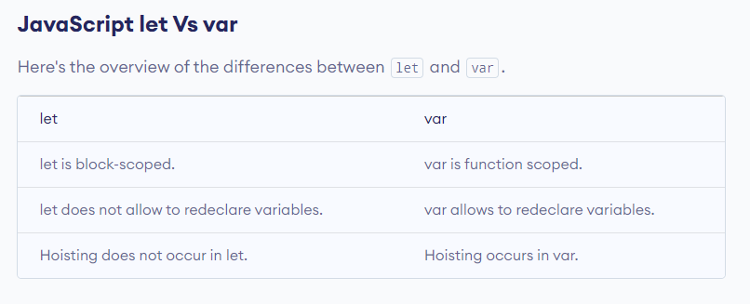

Resource Link: <https://www.programiz.com/javascript/let-vs-var>